## LAB # 7

### OPEN-ENDED LAB

##### OBJECTIVE

The objectives for the tasks involve string analysis, dataframe manipulation, and predictive modeling techniques like KNN, Naïve Bayes, Decision Trees, Linear regression and K-Means Clustering,

##### Lab Task:

**Task:1** Using a dictionary that holds information on students' scores, generate a pandas DataFrame from the provided data. Implement forward fill to interpolate any missing values in the DataFrame.

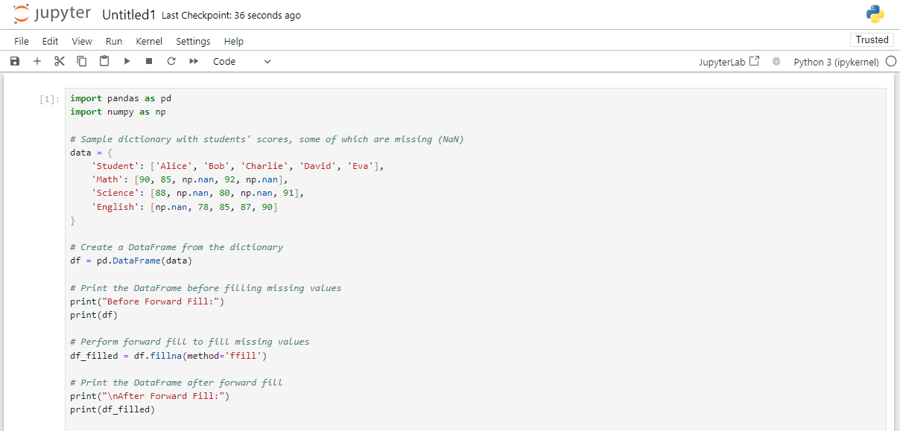**CODE:**

**OUTPUT:**

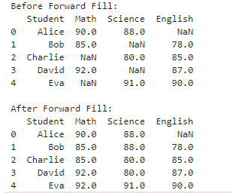

**Task:2** You are a data analyst working for a university. The administration wants to predict student performance in a particular course based on their past academic records. Your task is to design and implement a machine learning model.

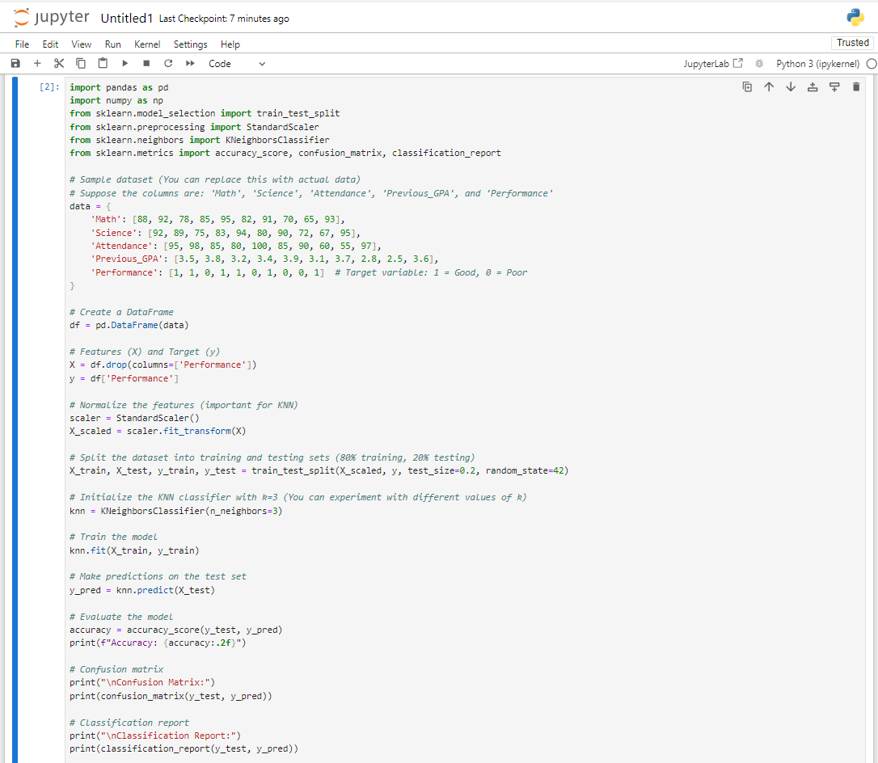**CODE(KNN):**

**OUTPUT:**

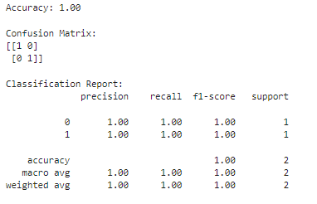

**Task:3** The bank wants to develop a system to classify loan applicants as either "high risk" or "low risk" based on their credit history and other factors. Your task is to design and implement a machine learning model.

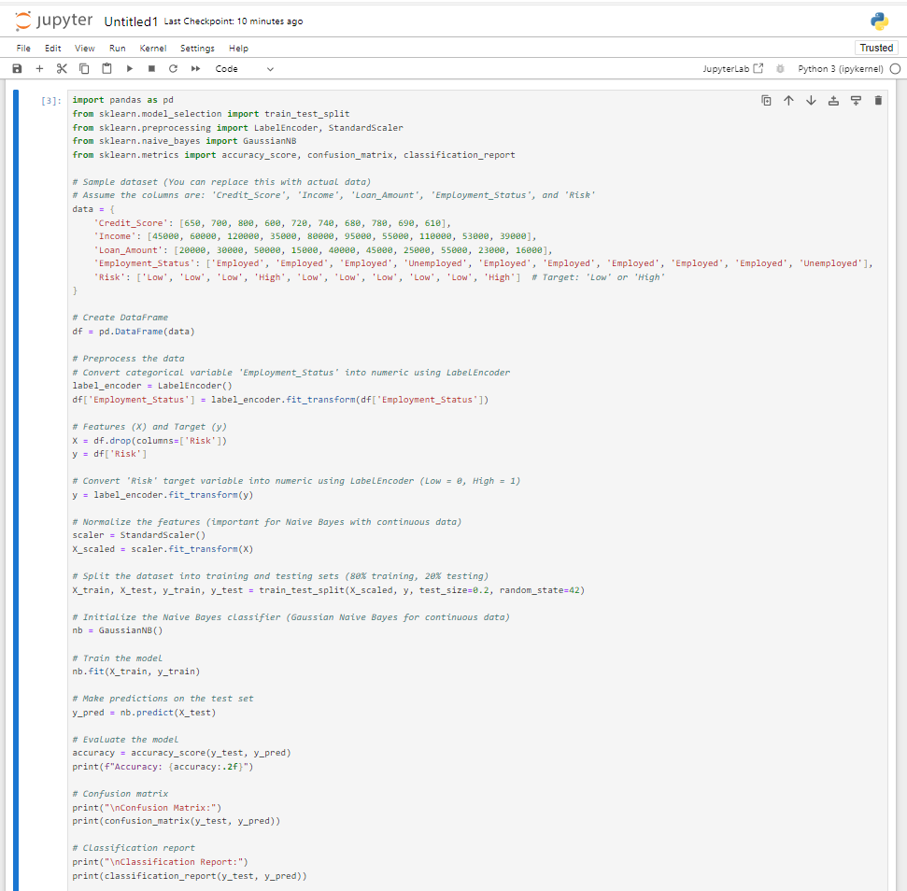**CODE (Naïve Bayes):**

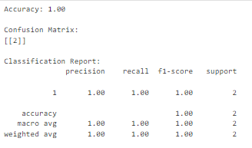 **OUTPUT:**

**Task:4** A company wants to develop a system to classify emails as either "spam" or "not spam" based on the email's content.

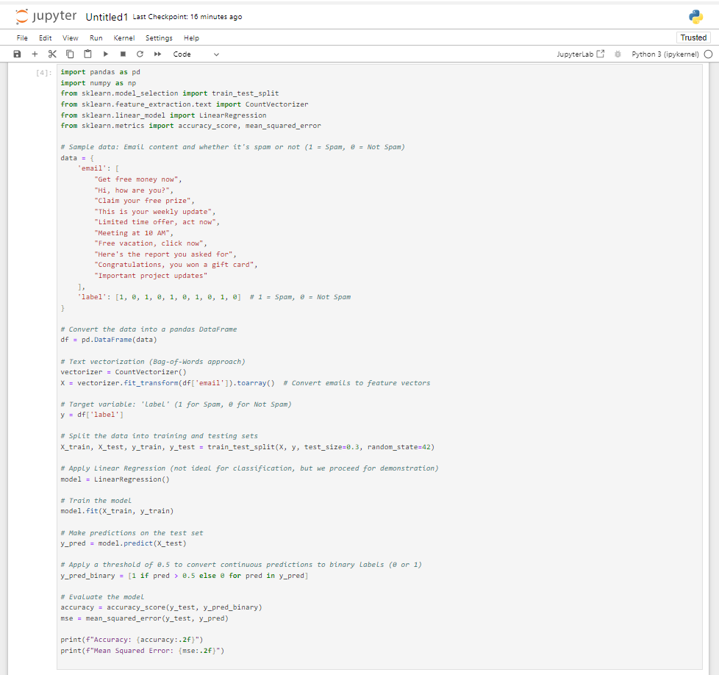**CODE (Linear Regression):**

**OUTPUT:**



**Task:5** Let us consider a hospital wants to develop a system to diagnose patients with either "disease A" or "disease B" based on their symptoms.

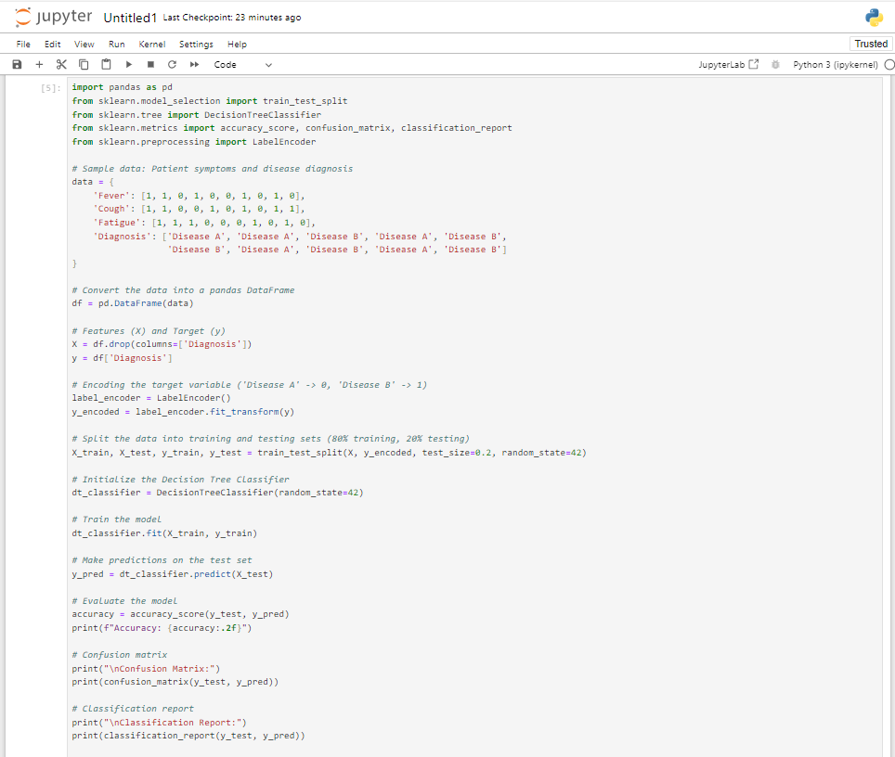**CODE (Decision Tree):**

**OUTPUT:**

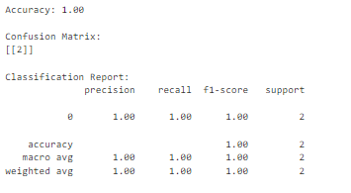

**Task:6** A real estate company wants to predict the prices of houses based on their features.

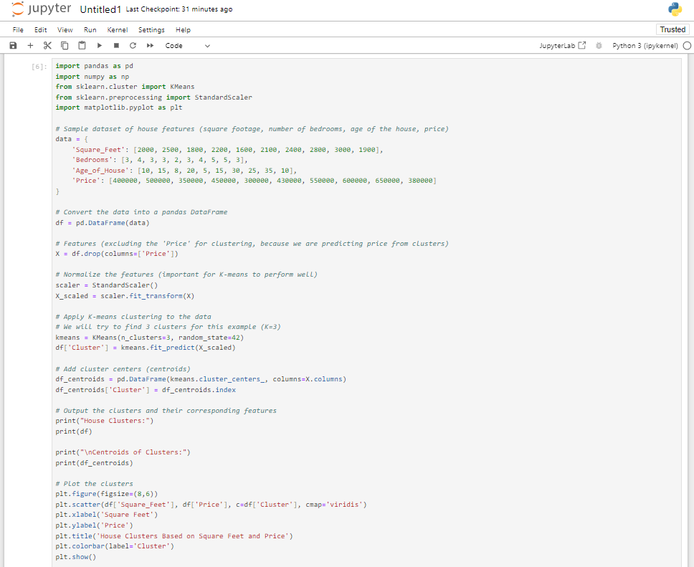**CODE (K-Mean Clustering):**

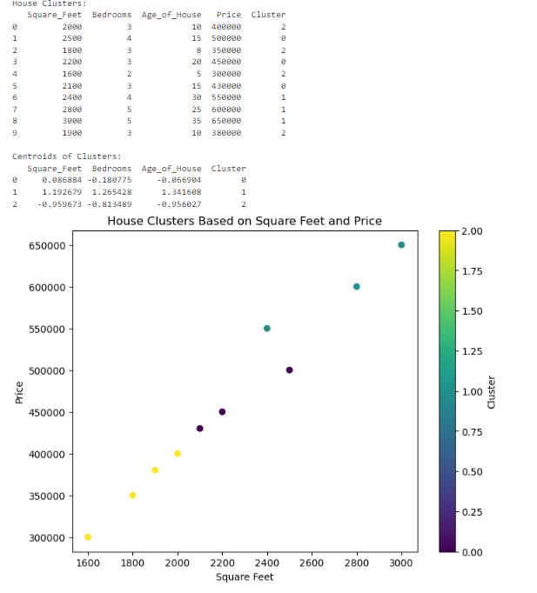**OUTPUT:**